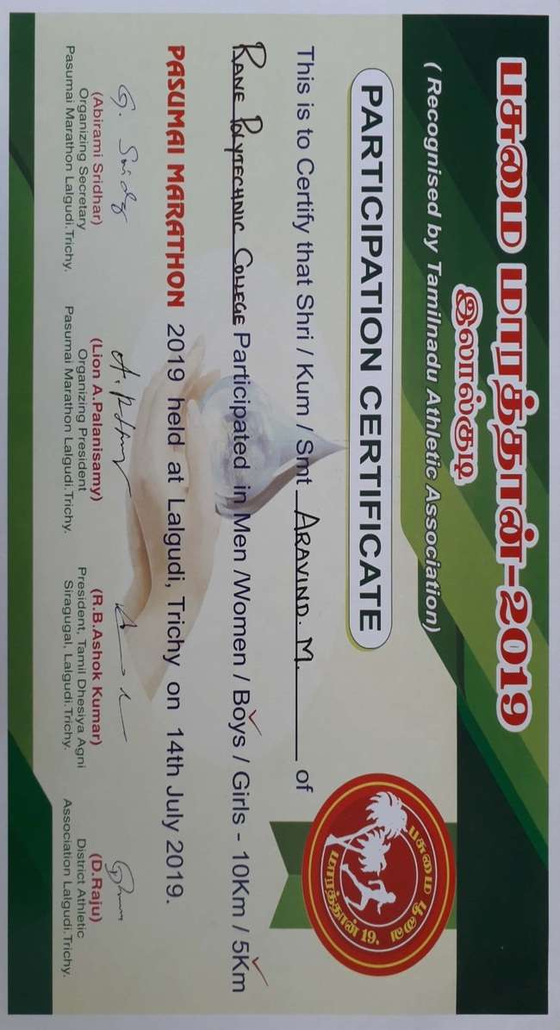
GREEN MARATHON ON 14.07.19 AT LALGUDI

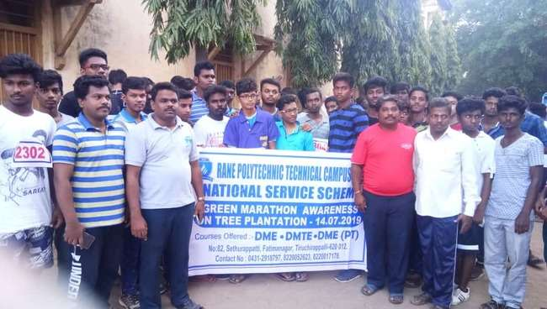
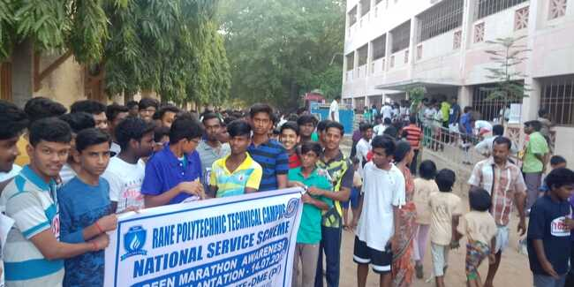

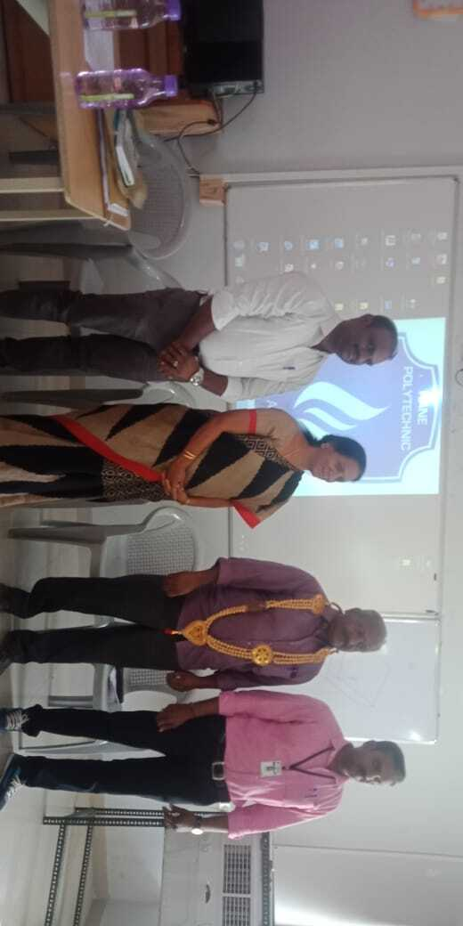
IPAA GENERAL BODY MEETING ON 31.07.19 AT RANE POLYTECHNIC TECHNICAL CAMPUS

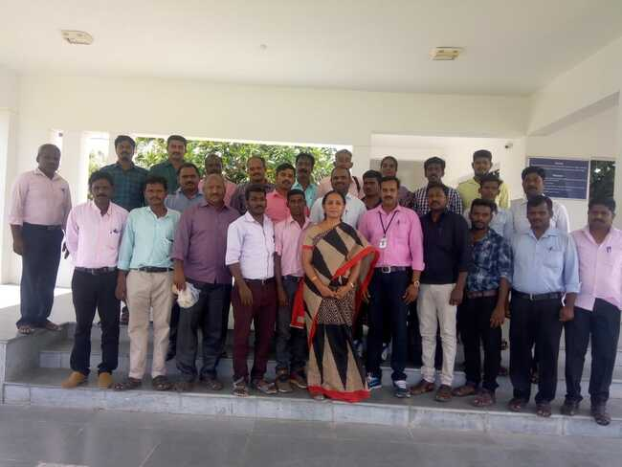

TRICHY DISTRICT ATHLETIC TOURNAMENT ON 02.08.19 AT ANNA STADIUM TRICHY.

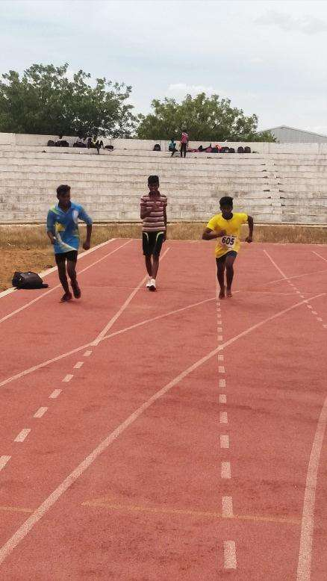

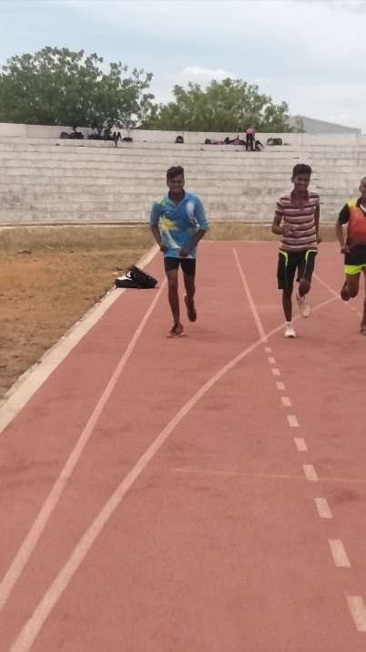

OUR COLLEGE STUDENT WON IV PLACE IPAA CHESS TOURNAMENT ON 24.8.19 AT SIT POLYTECHNIC COLLEGE,TRICHY.

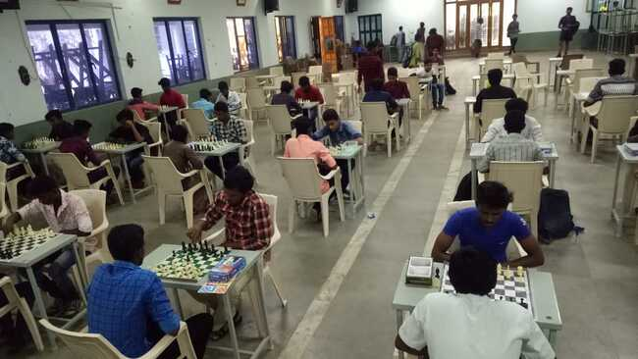

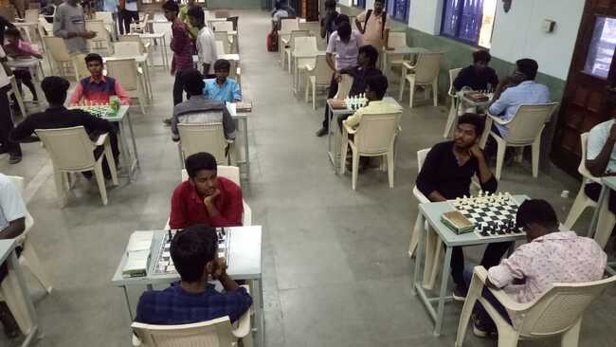

OUR COLLEGE STUDENT WON II PLACE IPAA CARROM TOURNAMENT ON 24.8.19 AT SIT POLYTECHNIC COLLEGE,TRICHY.

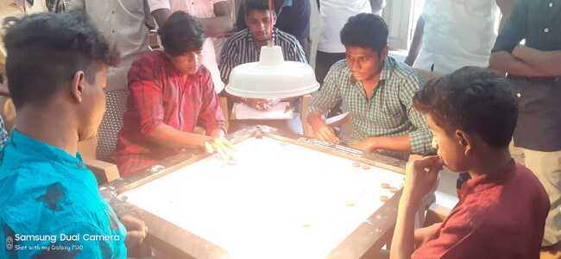

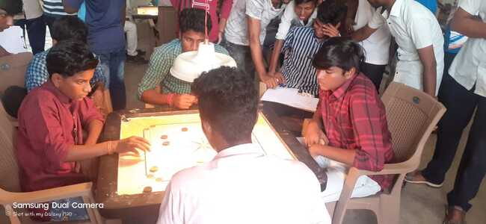

RANE POLYTECHNIC TECHNICAL CAMPUS CONDUCTED THE IPAA KHO-KHO TOURNAMENT ON 21.09.19 AT OUR CAMPUS

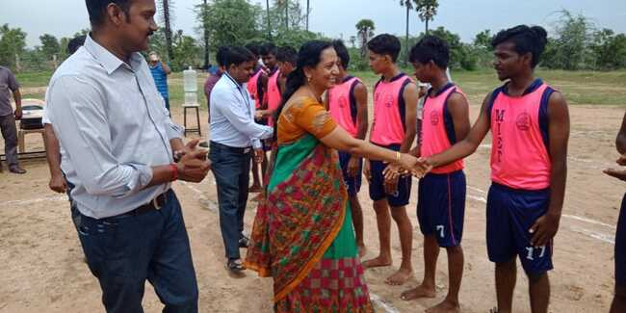

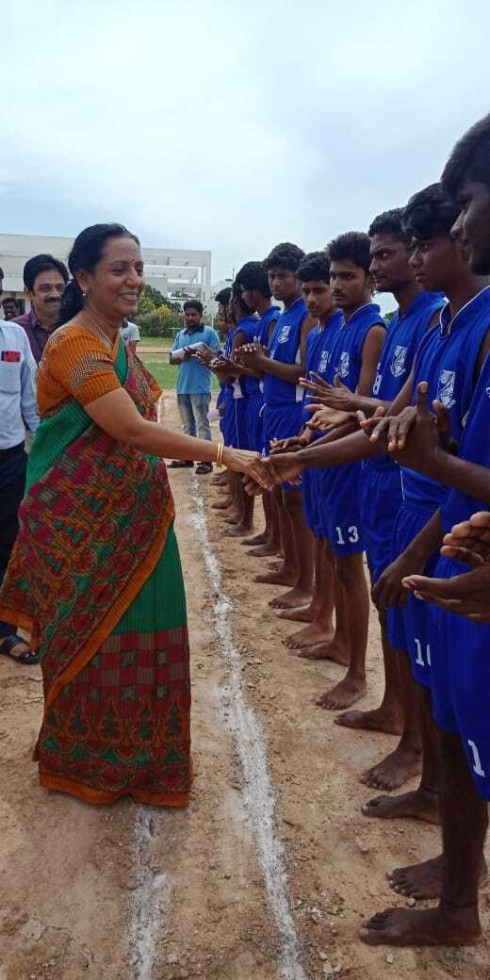

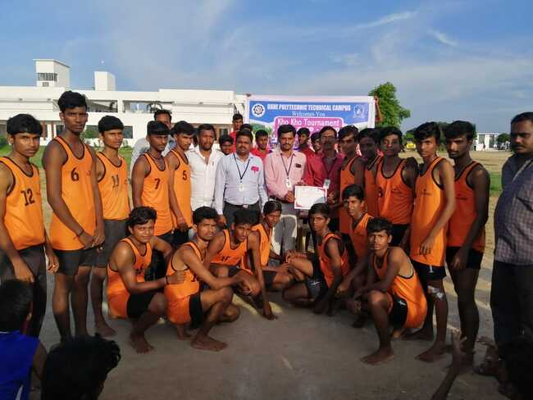

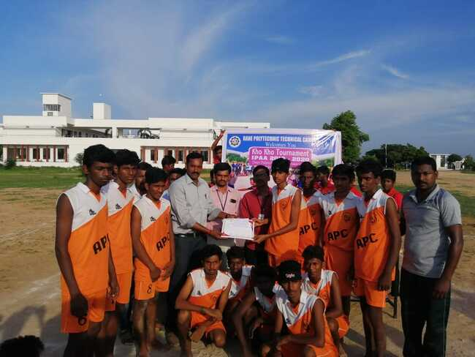

OUR COLLEGE STUDENTS PARTICIPATED IN IPAA VOLLEY BALL TOURNAMENT ON 27.09.19 AT MAM POLYTECHNIC COLLEGE, TRICHY

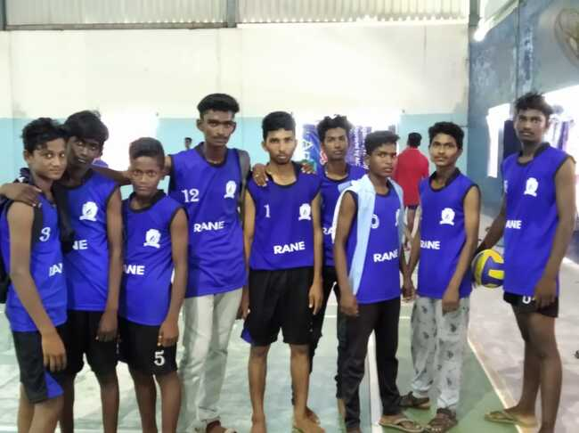

RANE POLYTECHNIC TECHNICAL CAMPUS PARTICIPATED THE CAUVERY MARATHON ON 29.09.19 AT TRICHY.

